

University of Engineering & Technology Mardan
Department of Computer Software Engineering

Submitted By | Umar Hayat
Semester | 6th, Spring 2026
Registration No | 23MDSWE274
Batch | 06
Subject | HCI Lab
Submitted To | Dr. Hamid Ullah
Lab Task # 04

Task 01:
Draw a storyboard depicting your project concept.

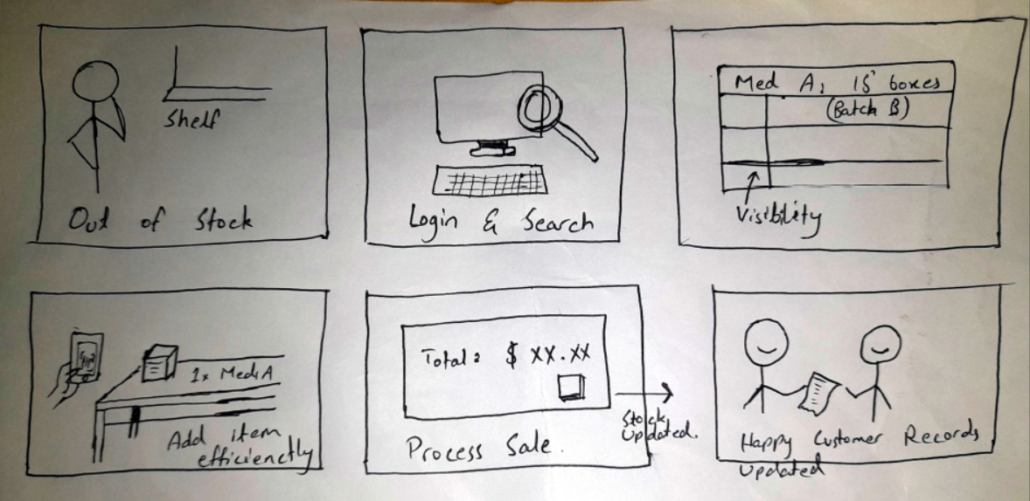

Task 02:
Draw the low fidelity prototypes of your project.
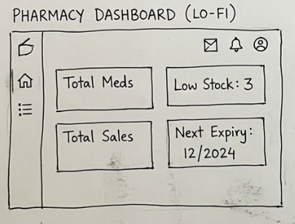
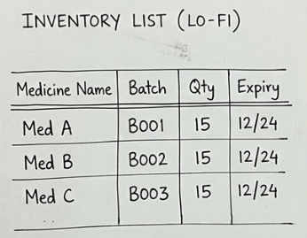

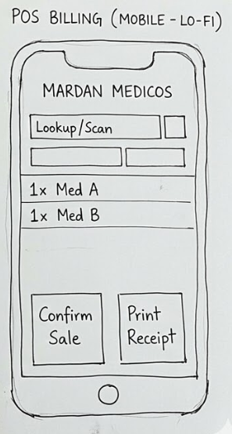

Task 03:
Draw the High fidelity prototypes of your project (e.g in Figma).

